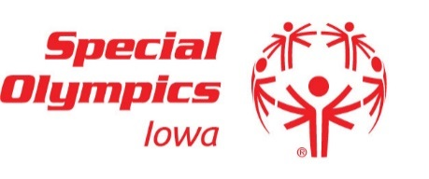
Conference Call In Number 669-224-3412
The code is 361-319-797 and then press #. They will then ask you for a pin. You do not need to type in a pin.

2019 Board Meetings Schedule

Wednesday, February 6th | 5:30pm
Wednesday, May 8th | 5:30pm
Wednesday, September 11th | 5:30pm
Wednesday, December 4th | 5:30pm

Meetings are held at the Special Olympics Iowa state office.
551 SE Dovetail Rd. Grimes, IA 515-986-5520

