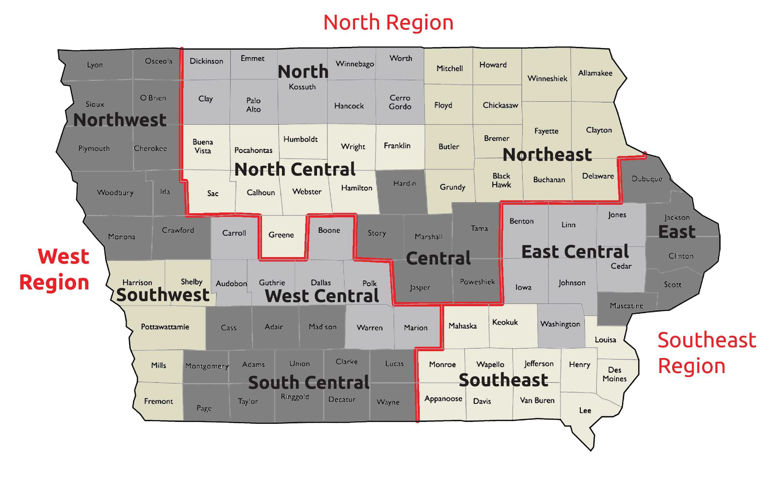

Northwest Area Director: Peg Koele

South Central Area Director: Dawn Criss

Southeast Area Director: Brad Benge, Julie Benge

Southwest Area Director: Martin Wright, Will Schafer

West Central Area Director: Debby Eldred

West Region: Bruce Wilson

Southeast Region: Erin Birkenholtz

North Region: TBD

Central Area Director: Jennifer Hart

East Area Director: Nancy Shannon, Jane Berhgendahl

East Central Area Director: Erin Birkenholtz

North Area Director: Andrew Fisher

North Central Area Director: Liz Rusher, Lee Decicco

Northeast Area Director: Alexis Thorne, Alice Miller