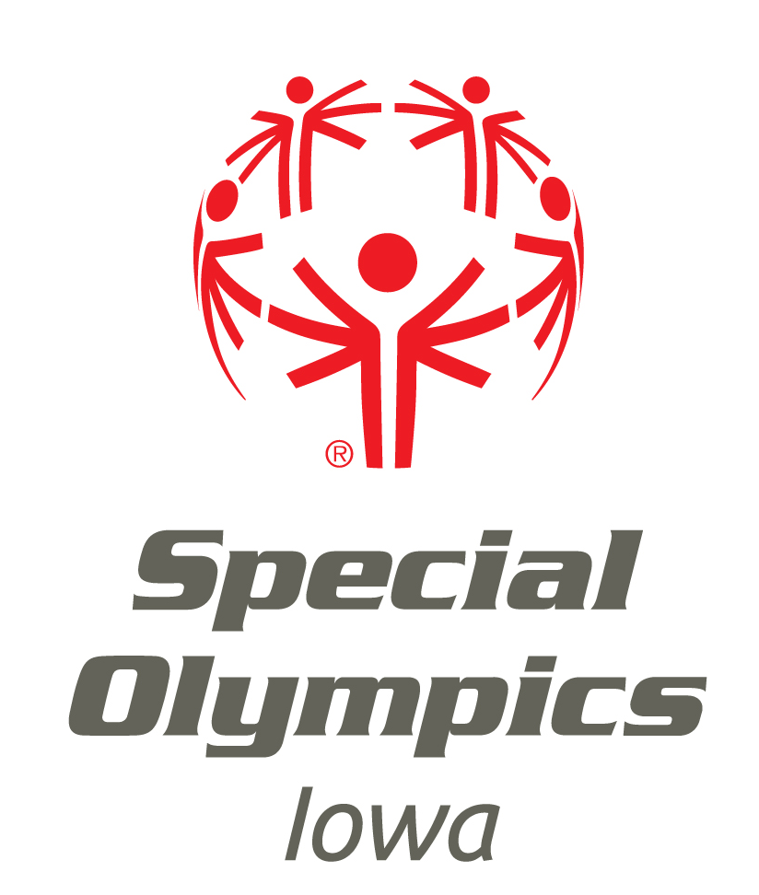

The Mission of Special Olympics
is to provide a year-round sports training
and athletic competition
in a variety of Olympics-type sports
for individuals with intellectual disabilities
by giving them continuing opportunities
to develop physical fitness,
demonstrate courage,
experience joy and
participate in sharing of gifts, skills, and friendship
with their families, other Special Olympics athletes
and the community.

