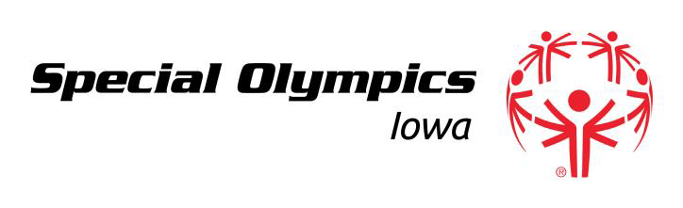

Board of Directors Work Session & Meeting Agenda
SOIA State Office, 551 SE Dovetail Road, Grimes, IA 50111
Monday, September 19, 2016
5:30 pm – 7:30 pm
BOARD MEETING AGENDA

5:30 Welcome- Jill Southworth

5:35 Athlete Update- Charity Hodson

5:45 Acceptance of Prior Meeting Minutes *- Jill Southworth

5:50 CEO Update- Gary Harms

6:00 Departmental Updates

- Development Report*- Gary Harms
- Program Report*- Gary Harms
- Financial Report*- Brian Wessels/Jeremiah Johnson

6:15 By Law Changes*- Stu Sorrel

7:00 Board Election Nomination Process – Lana Voga

7:15 Closed Session- Jill Southworth

7:30 Adjournment- Jill Southworth

* Board Approval required

