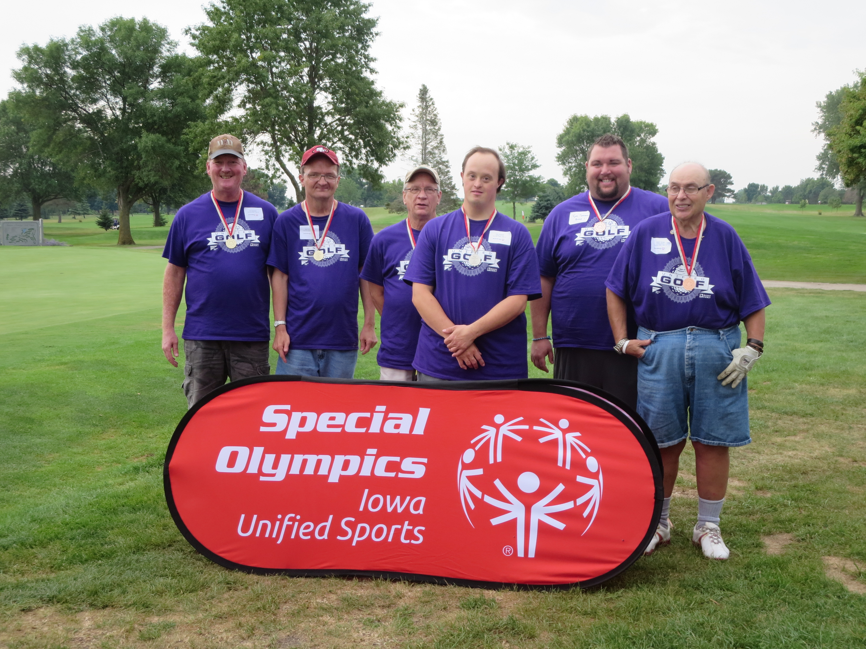

You are invited to the 2017 Spencer Unified Golf Tournament on
Sunday, August 13, 2017.
Special Olympics Iowa athletes will be paired with a Unified Partner for the day to play either 3, 6 or 9 holes of golf.
The Unified Sports program is a fundamental part of our mission as it promotes inclusion and friendship for all.
Get your teams registered for this day of fun!

Event Information
Sunday, August 13, 2017
Spencer Municipal Golf Course
1320 4th Ave. SW, Spencer, IA 51301
Registration begins at 8:00 AM

The first group will tee off at 8:30 AM. There is no fee to register and all participants will receive a t-shirt and lunch.

Enclosed you will find the registration form. All Special Olympics athletes must have a current physical on file at the State Office in order to compete in this event.
Once the registration form is complete, please send all materials to the State Office at registrations@soiowa.org no later than Monday, July 24, 2017.
Please contact Bryan Coffey with questions.

