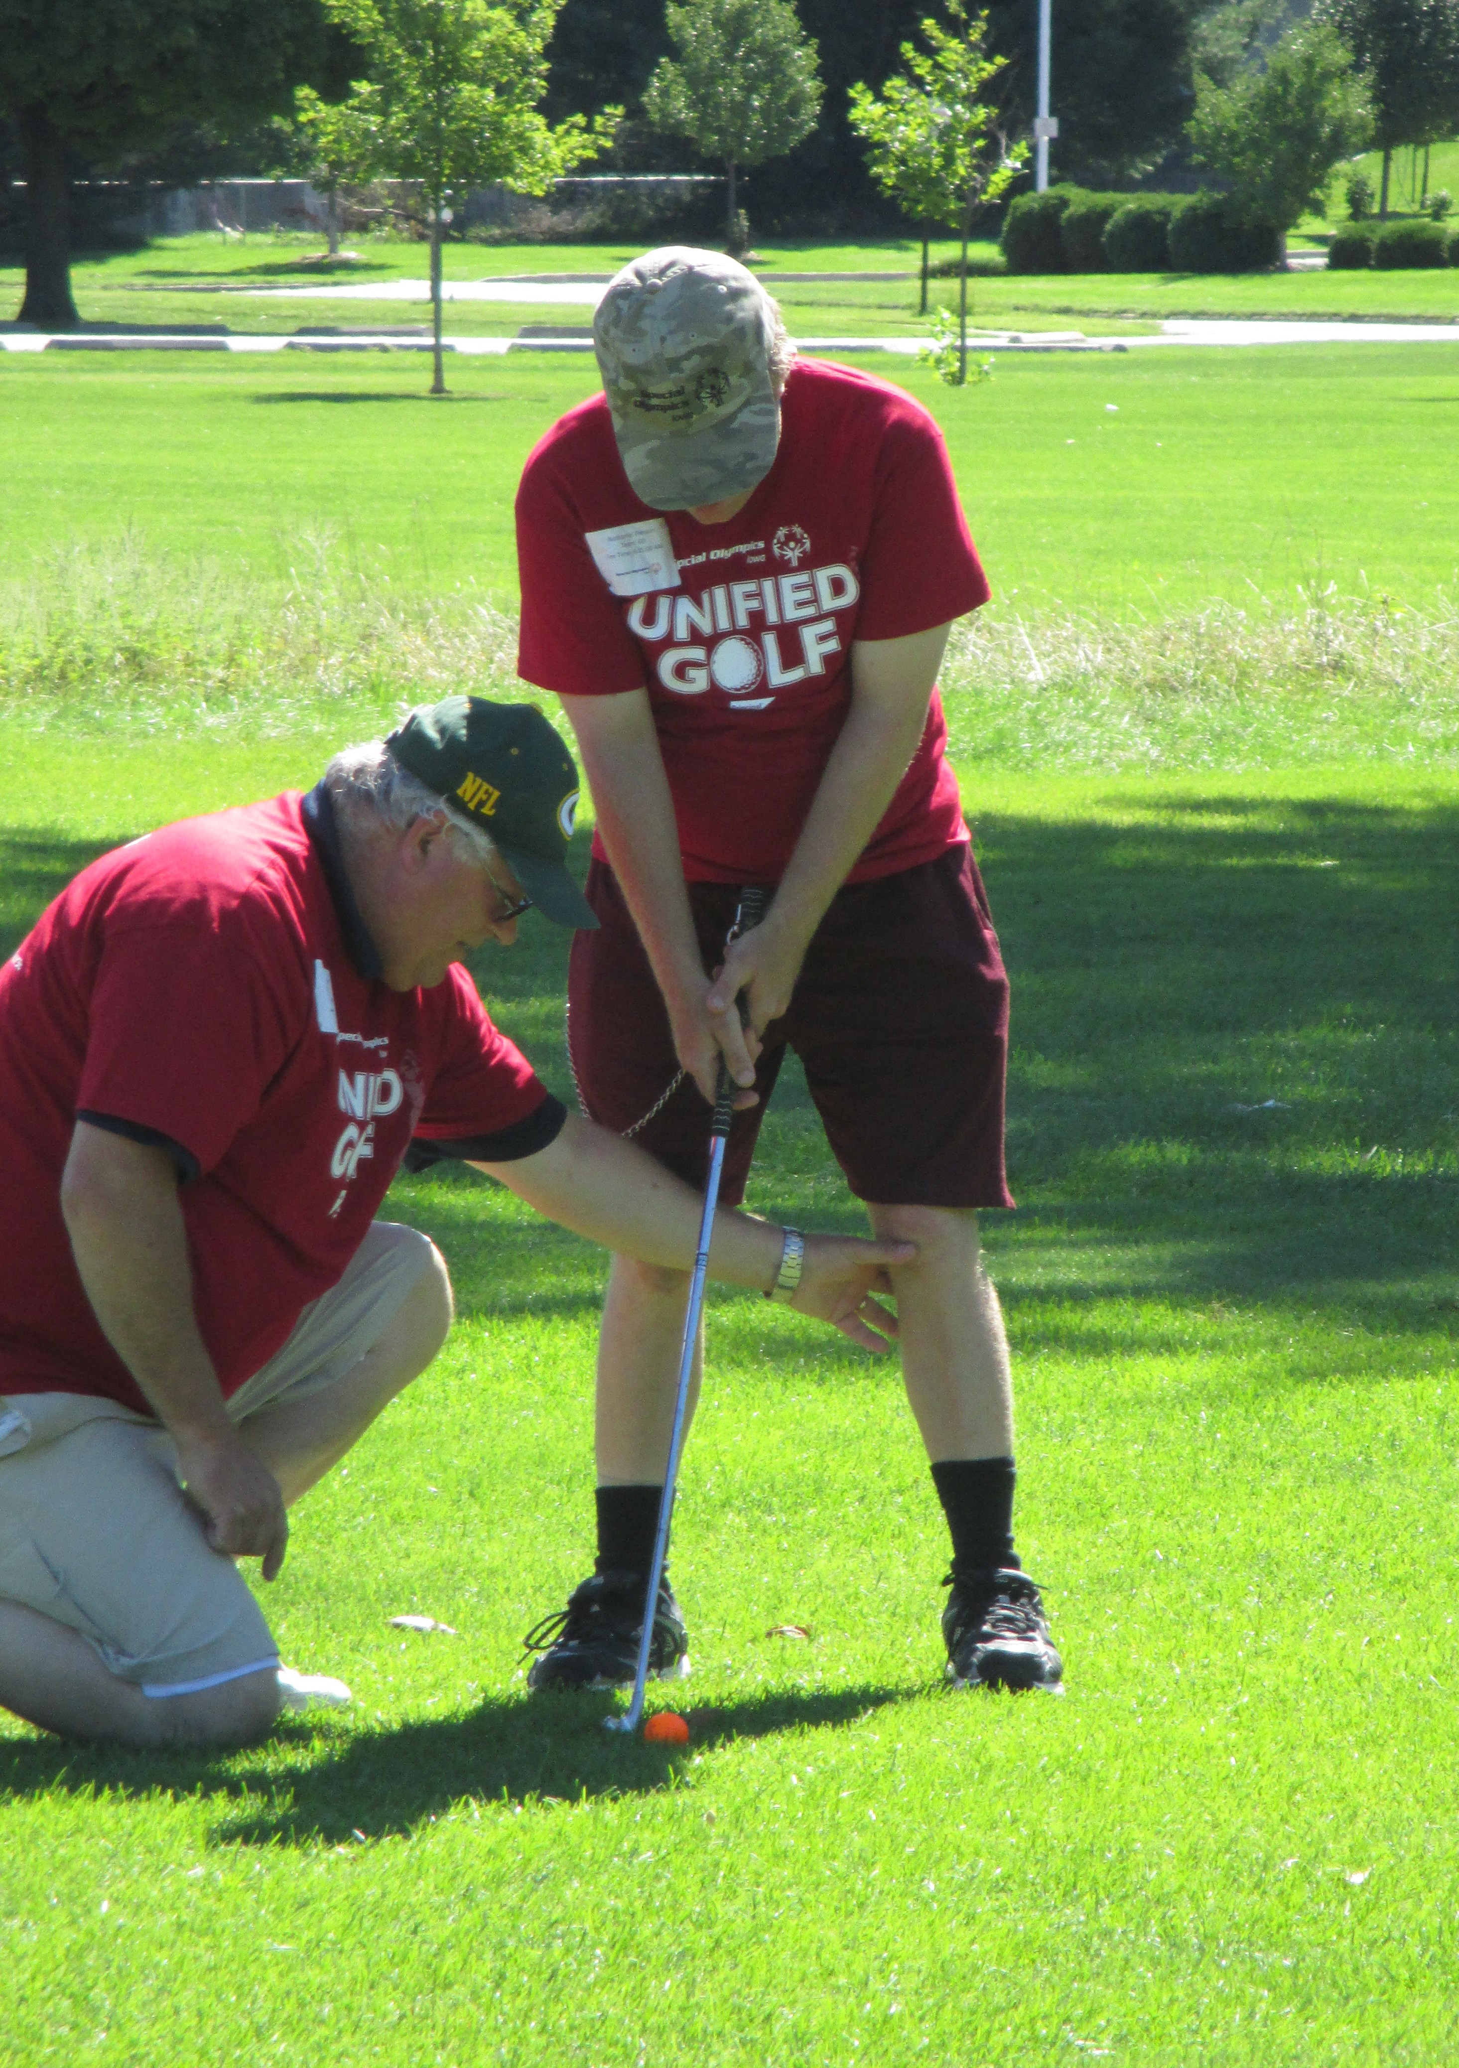
You are invited to the 2017 Cedar Rapids Unified Golf Tournament on
Saturday, August 26, 2017.

Special Olympics Iowa athletes will be paired with a Unified Partner for the day to play either 3 or 9 holes of golf.
The Unified Sports program is a fundamental part of our mission as it promotes inclusion and friendship for all.
Get your teams registered for this day of fun!

Event Information
Saturday, August 26, 2017
Twin Pines Golf Course
3800 42nd St. NE, Cedar Rapids, IA 52402
Registration begins at 8:00 a.m.

The first group will tee off at 8:30 a.m. There is no fee to register and all participants will receive a T-shirt and lunch.

Enclosed you will find the registration form. All Special Olympics athletes must have a current physical on file at the State Office in order to compete in this event.

