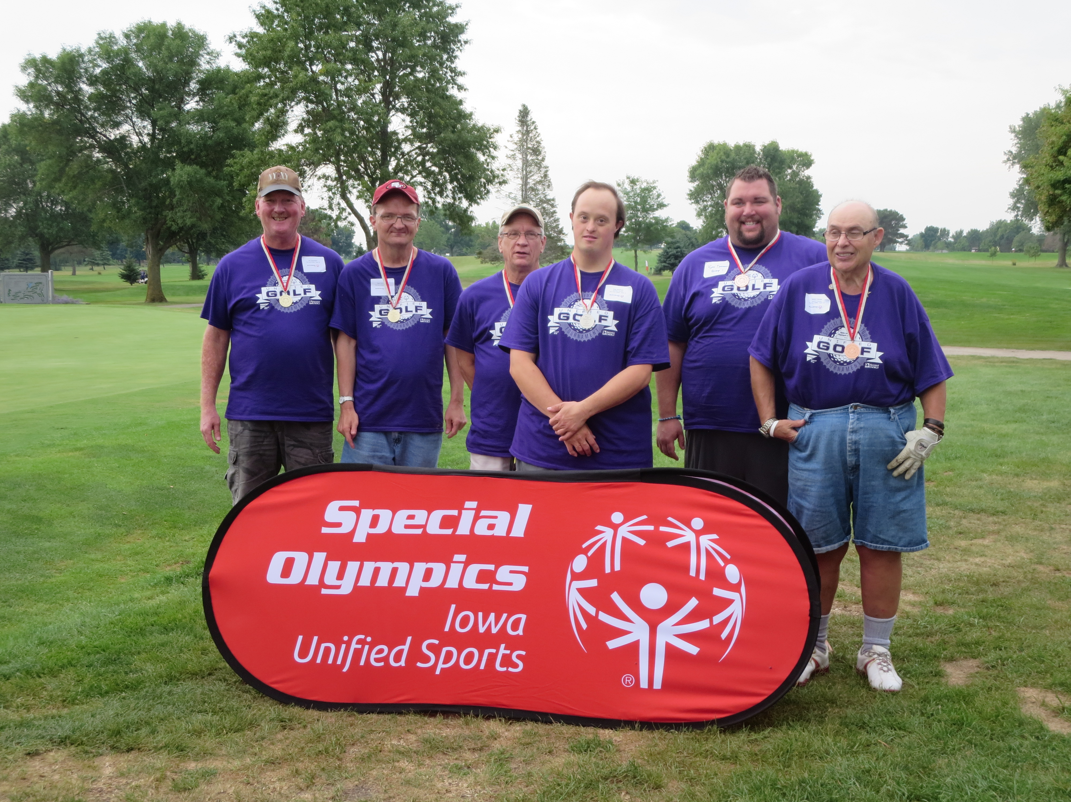

You are invited to the 2017 Akron Unified Golf Tournament on
Saturday September 30, 2017.
Special Olympics Iowa athletes will be paired with a Unified Partner for the day to play 9 holes of golf.
The Unified Sports program is a fundamental part of our mission as it promotes inclusion and friendship for all.
Get your teams registered for this day of fun!

Event Information
Saturday September 30, 2017
Akron Club House
941 Country Club Dr. Akron, IA 51001
Registration begins at 9:00 AM

Golfers need to arrive for registration at 9:00amThere is no fee to register and all participants will receive a t-shirt and lunch.

Enclosed you will find the registration form. All Special Olympics athletes must have a current physical on file at the State Office in order to compete in this event.
Once the registration form is complete, please send all materials to the State Office at registrations@soiowa.org no later than Friday, August 25, 2017.
Please contact Bryan Coffey with questions.

