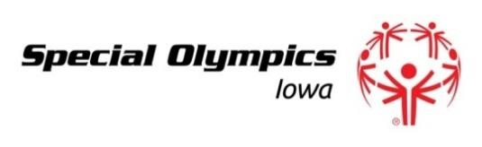
Summer Games Team Bocce Quota Request Form
(Form must be sent to registrations@soiowa.org by February 15)

Delegation Name: ________________________________________ Area: _____________________________
Head Coach/Delegation Contact: ______________________________________________________________
E-mail: ________________________________________________
Phone: ________________________________________________
The State Office is in the process of organizing the Summer Games Bocce Tournament. To fairly allocate the 110 team slots available for bocce please let us know the maximum number of teams your delegation would like to have in the tournament. The team tournament will be held on the first day of the Summer Games (Thursday).

We will determine the final allocations of bocce teams based on the completed quota request forms received from each delegation. Once the allocations are determined, it will be up to the individual delegations to determine how they will choose the teams advancing to Summer Games. Each delegation will receive at least one bocce team for Summer Games. Delegations will be notified of the competition allocations by February 28.

SOIA will offer a bocce skills competition for athletes just learning the sport of bocce. Athletes competing in skills are not eligible to compete in the team or singles competitions. The skills competition will be held on the first day of the Summer Games (Thursday). The singles tournament will be held on the second day (Friday).

All bocce entries (team, singles & skills) along with all other Summer Games registration material is due to registrations@soiowa.org by March 26.

Thank you for your assistance. Please contact Rhonda Schwarzkopf at rschwarzkopf@soiowa.org or Sally Briggs at sbriggs@soiowa.org if you have any questions. You may also contact our office at 515-986-5520.

Please indicate the maximum number of teams (not athletes) you would like to bring in each level listed:

_____ Junior Bocce Teams _____ Senior Bocce Teams _____ Unified Bocce Teams

_____ Ramp Bocce Teams (all athletes must use a ramp to qualify for this category)

Please return this form by February 15 to registrations@soiowa.org or 551 SE Dovetail Rd, PO Box 620, Grimes, IA 50111-0620. If your form is not received by the deadline you may not receive an allocation for the Summer Games Bocce Tournament.
Revised July 2017

